American Council of the Blind
of Virginia

2025 Hybrid Convention
Hilton Garden Inn, Fredericksburg, VA
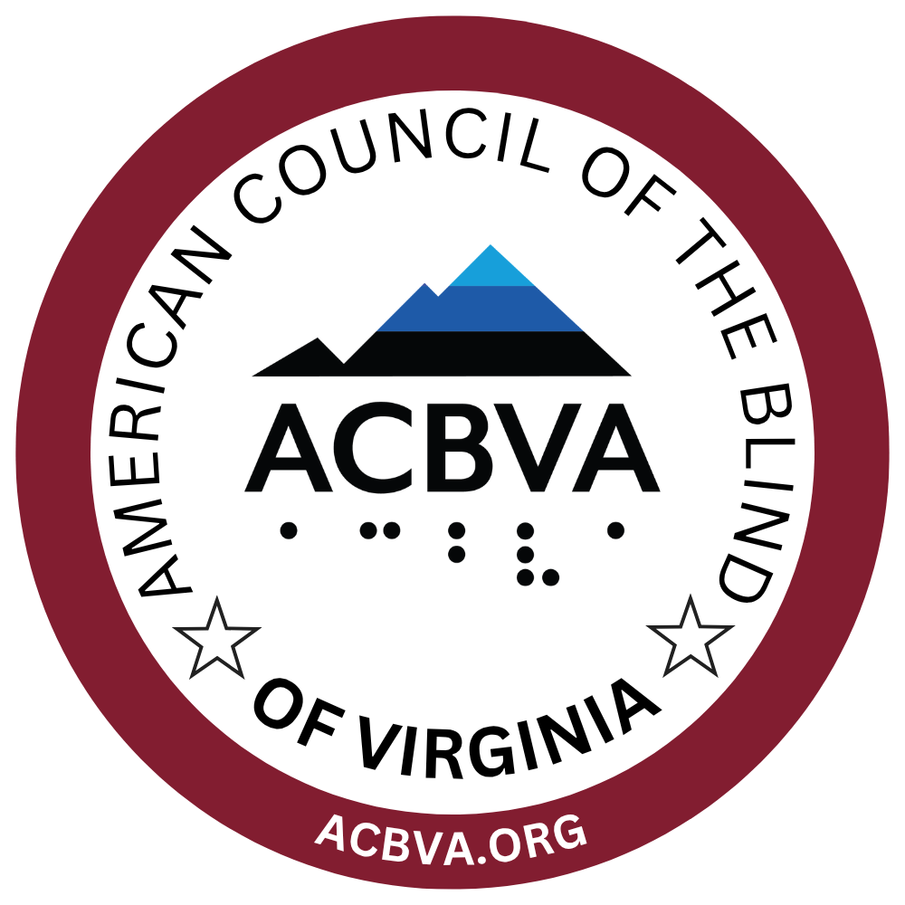

“Together Again:
Reconnect, Recharge, and Rise!”
Table of Contents

Welcome to the ACBVA 2025 Hybrid Convention! 4
Sponsors 6
Individual Sponsors 6
Corporate Sponsors 7
ACBVA 2025 State Convention Program Agenda 12
Friday, October 17: Welcome & Warmth 12
Saturday, October 18: Learn, Laugh & Lead 13
Sunday, October 19: In the Future 17
What to Expect at Convention 20
Hotel Orientation 20
Guide Dog Relief 21
Zoom Links for Virtual Convention Participants 21
Transportation 21
Food Highlights 22
Assistive Technology Consultations 23
Special Raffle – Computers for the Blind (CFTB) 23
50/50 Raffle 23
Door Prizes 23
Silent Auction 24
Display of Visual Diagrams in Accessible Forms for Blind and Visually Impaired Individuals 24
2025 ACBVA Exhibitors 25
A P Real Oils and More 25
Ability2Access (A2A) 26
Breeden Inspirations 27
disAbility Resource Center of the Rappahannock Area, Inc. (dRC) 28
Enhanced Vision 30
Foundation Fighting Blindness 33
Guiding Eyes for the Blind 34
JW.org 36
Lions 37
National Industries for the Blind (NIB) 39
Patriot Vision Industries 41
Prevention of Blindness Society of Metropolitan Washington 42
Selvas BLV 43
Sportable Richmond Adaptive Sports and Recreation 44
Vanda Pharmaceuticals 45
Virginia Department for the Blind and Vision Impaired 46
Visionary Solutions 48
Goodie Bag and Door Prize Contributors 50
In Gratitude 52
ACBVA 2024-2025 Board of Directors 57

Welcome to the ACBVA 2025 Hybrid Convention!

Dear ACBVA Members, Friends, Exhibitors, and Sponsors,

It’s my pleasure to welcome you to the first-ever hybrid convention of the American Council of the Blind of Virginia (ACBVA)! After several years of meeting virtually, we’re thrilled to finally bring back the in-person experience—while keeping the convenience of Zoom for those joining from afar.

Our growing membership has made it possible to organize what promises to be a dynamic and memorable weekend:
Friday Evening: Kick things off with a lighthearted icebreaker, tasty appetizers, and our ‘Lead the Way: Igniting Leadership in ACB Virginia’ workshop—perfect for both new and longtime members.

Saturday: A full day of learning and connection, featuring sponsor and exhibitor showcases, tech and low-vision solutions, emergency preparedness, state-level advocacy, and falls prevention.

Saturday Night: Enjoy our banquet, where Debra Hill will inspire us as our featured speaker—followed by a silent auction and karaoke fun, all to benefit ACBVA.

Sunday: Our Annual Membership Business Meeting will include reports about what your organization has been doing and what we hope to do this coming year, proposed Bylaws, elections for open Board seats, followed by updates from the Department for the Blind and Vision Impaired (DBVI), and a public hearing.

Perhaps best of all, this weekend gives us the chance to finally meet—face to face—the wonderful friends we’ve only seen on Zoom! While you’re here, don’t forget to renew or join. Membership is just $13 through the end of October, even if dues increase to $15 after the Annual Membership Business Meeting and adoption of the new Bylaws.

I encourage you to take time to connect, learn, and celebrate our shared mission. None of this would be possible without the incredible volunteers who devoted countless hours to make this convention happen. Please join me in thanking them for their hard work and dedication.

Thank you for being part of ACBVA and for all you do to strengthen our community. I look forward to seeing—and hearing—you throughout the weekend!

With warm regards,
Doug Powell
President, American Council of the Blind of Virginia

Sponsors

Our sincere gratitude goes to all the below sponsors who contributed at least $250 to support our convention.

Individual Sponsors

- Jim and Davida Luehrs: Reston, Virginia
- Martin Pfeiffer: Springfield, Virginia
- Chris Jennings: Arlington, Virginia
- Larry Moye: West Boylston, Massachusetts
- Patricia Brown Reedy
- Reverend JanettaRose Green &
Maria Dipasquantonio: Maclean, Virginia

Corporate Sponsors

Aquilano Salon
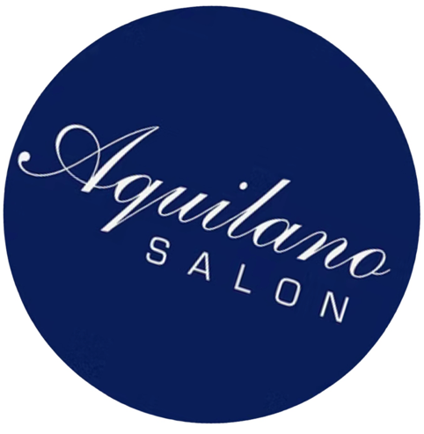

Logo description: Blue circle with white text "Aquilano Salon"

Website: https://www.aquilanosalon.com/
Contact Person: John Pascazio
Phone: 703-683-0755
Email: aquilanosalon@me.com

Computers for the Blind (CFTB)
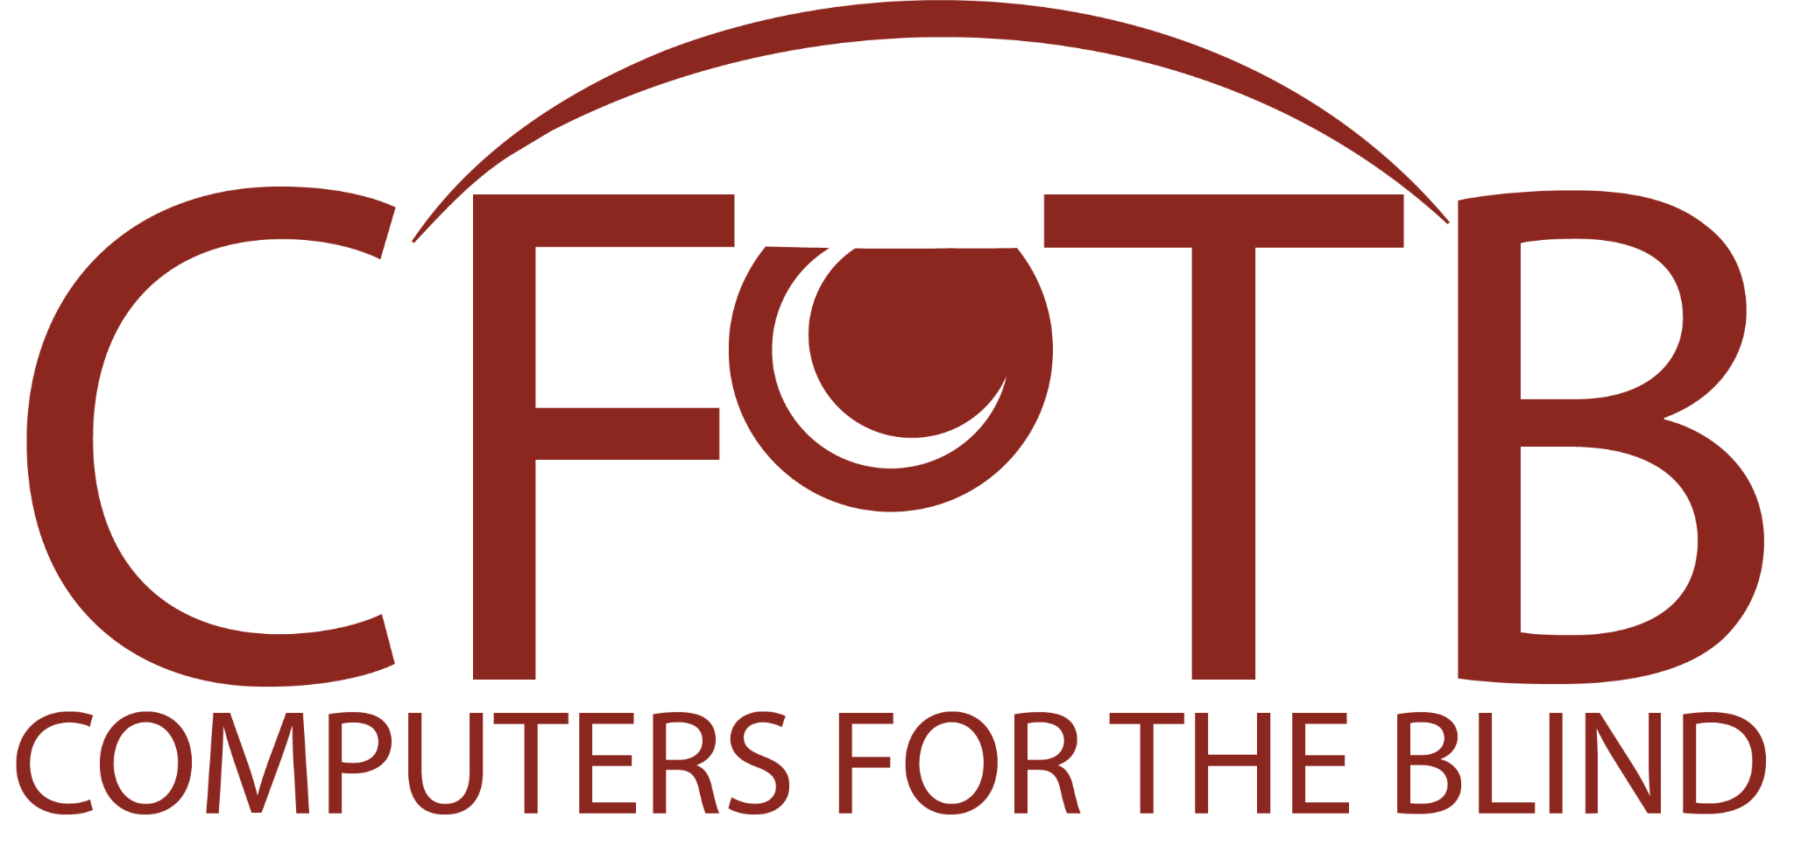

Logo description: Letters C F T B over the words Computers for the Blind

OPENING WORLDS - ONE COMPUTER AT A TIME
Website: https://computersfortheblind.org/
Contact Person: Stacy Turos
Phone: 214-340-6328
Email: outreach@computersfortheblind.org

iBUG Today
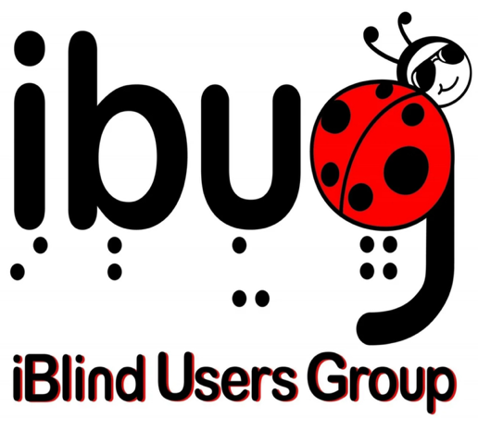
Logo description: A ladybug forms the letter G in ibug. iBlind Users Group

Website: https://ibugtoday.org/
Contact Person: Michael McCulloch, President
Phone: 832-453-7139
Email: mdmcculloch1@gmail.com
Contributed by: Sree Roy, Springfield, VA

Selvas BLV



Logo description: The words Selvas BLV

Website: https://selvasblv.com/
Contact Person: Earl Harrison, National Account Manager
Phone: 512-914-1925
Email: earle@selvasBLV.com

Vanda Pharmaceuticals



Logo description: The word VANDA over the word Pharmaceuticals Inc.

Website: https://www.vandapharma.com/
Contact Person : Maggie Felton,
Clinical Nurse Educator – Patient Outreach
Non-24 Sleep Wake Disorder
Phone: 202-579-8035
Email: Maggie.felton@vandapharma.com
# # #

ACBVA 2025 State Convention Program Agenda
October 17–19, 2025
Hilton Garden Inn – Madison Room
Fredericksburg, Virginia (540) 548-8822
Theme: Together Again – Reconnect, Recharge, and Rise!
Pet-friendly hotel — welcoming guide dogs and support animals!
# #

Friday, October 17: Welcome & Warmth

4:30 pm - Check In at Registration Desk just outside Madison Room—and pick up your goodie bag!

5:30 PM – Hospitality Hour
Kick off the weekend with light refreshments, friendly faces, and the chance to reconnect in a relaxed setting.

6:00 PM - Special Welcome
We’re honored to kick off our convention with a warm welcome from Kerry Devine, Mayor of Fredericksburg, Virginia. Join us as Mayor Devine greets attendees and helps us officially open the 2025 ACBVA Hybrid Convention!

6:30 PM – Icebreaker: “Oops, I Did What?”
Laughter guaranteed! Hear hilarious and humbling stories from fellow members about life’s blind moments. Hosted by the delightful Robin Hoerber and Margie DeMars.

7:00 PM – Hybrid Convention Officially Kicks Off!
Enjoy the start of our hybrid weekend—where in-person and online participants come together as one community.

7:00 PM – Workshop: Lead the Way – Igniting Leadership in ACB of Virginia
Led by ACBVA leader and President Doug Powell and experienced facilitator and leader Jeremy Grandstaff, this session will help you explore your leadership potential, gain practical tools, and connect with others passionate about making a difference. Whether you’re curious about getting involved or already guiding a team, this workshop is for you.

8:30 PM – Adjourn for the Day
Want to keep the conversation going? Join fellow attendees in the hotel lobby or at the hotel bar for casual drinks and connection!
# #

Saturday, October 18: Learn, Laugh & Lead

7:30 AM – Breakfast
Start your day with great food and even better company. Served in the hotel lobby.
9:00 AM – Our hybrid convention keeps rolling!
Join us as the morning sessions continue—featuring engaging speakers, interactive discussions, and plenty of opportunities to connect from wherever you are.
9:00 AM – Welcome & Agenda Overview
Doug Powell and RoseAnn Ashby will welcome everyone and preview what’s ahead.

We’ll begin with the Pledge of Allegiance, led by Michaun Harrison, a blind veteran and ACBVA member, followed by a live performance of the Star-Spangled Banner sung by ACBVA’s own Lisa Calhoun.

9:30 AM – Session 1: Advocacy in Action – Get Involved, Make an Impact
Ready to turn your passion into real change? We will hear from two of our Virginia State delegates, Patrick A. Hope (District 1) and Rodney T. Willett(District 58). This dynamic session will equip you with tips and insider knowledge to advocate more effectively when we travel to Richmond this winter.

Facilitated by RoseAnn Ashby, you’ll learn how to amplify your voice and make a meaningful impact on policies that affect the blind and low vision community.

10:30 AM – Break
Grab some coffee, stretch your legs, and be sure to visit our vendors in the Washington Room.

10:45 AM – Session 2: Household Management – Tips & Tricks
Make life at home easier and safer by exchanging tips and techniques with other members in a lively discussion led by Sam Joehl and Vicki Ratcliffe.

11:45 AM – Break
This is another perfect time to meet with vendors or grab your chance to get a peek at the silent auction items—don’t miss those hidden gems!

12:00 PM – Vendor & Silent Auction Introductions
Donna Clarke will kick things off with a quick highlight of the silent auction—what’s available, how it works, and why your bids matter—before introducing our amazing vendors.
You’ll then hear lightning-round intros from vendors, so you know who to visit during lunch and throughout the day.

12:45 PM – Lunch & Vendor Showcase
Enjoy lunch while exploring innovative products and services tailored for the blind and low vision community.

2:00 PM – Session 3: Emergency Preparedness – Plan, Prepare, Protect
Donna Clarke and Crystal Goodwin, from Fairfax County Department of Emergency Management and Security, walk us through critical safety planning that’s both practical and empowering.

3:00 PM – Break
Vendors are standing by, and auction items are calling — take a few minutes to explore!

3:15 PM – Session 4: Falls Prevention – Stand Tall, Stay Safe
Larry Johnson, an ACB member from San Antonio, TX, who has given workshops from 1 hour to 8 weeks on Falls Prevention, and Doug Powell, a 20+ year Tai Chi teacher, combine to give hints to improve your environment and exercises to improve your balance with special focus on people who are blind or have low vision.

4:15 PM – Break
Final chance of the day to visit vendors and check out silent auction items before bidding begins!

4:30 PM – Session 5: Tech That Talks Back – Everyday Strategies for Navigating AI & Assistive Technology
Facilitated by Jeremy Grandstaff and Stan Gowin.
Discover how today’s smart tools can boost independence and simplify daily life. Whether you’re tech-curious or already plugged in, this session will explore how assistive technology and AI—from voice assistants to apps and smart home devices—can help you work smarter, navigate more confidently, and stay connected.
You’ll get real-life strategies, hands-on examples, and a chance to ask questions. No tech experience needed—just bring your curiosity!

5:30 PM – Free Time
Take a break, visit with friends, or grab a chance to talk to a vendor.
Bidding on auction items begins!

6:00 PM – Celebration Banquet & Keynote Address
Join us for a delicious dinner and an evening of inspiration featuring Debra Hill, motivational speaker, singer, and proud member of ACBVA.
Debra will share her story, voice, and vision for resilience and empowerment.
Learn more about her work and music at debrahillsings.com.

7:30 PM – Evening Fun: Entertainment, Social Hour & Silent Auction
Donna Clarke hosts an evening full of laughter, music, karaoke, and last-chance bidding on fantastic auction items. Auction winners will be announced at 8:30 PM.

9:00 PM – Adjourn for the Day
Still buzzing? Head to the lobby or the bar for a nightcap and more great conversation.
# #

Sunday, October 19: In the Future

7:30 AM – Breakfast
Ease into the final day with conversation and breakfast served in the hotel lobby. Take this final opportunity to claim your silent auction wins!

9:00 AM – Join us as we kick off the final day of our hybrid convention!
Tune in for the Annual Business Meeting, important updates, and engaging discussions as we wrap up a fantastic weekend together.

9:00 AM – Annual Membership Business Meeting
All members are encouraged to attend. We’ll vote on bylaws, elect Board members, and hear from our officers and committees.

Call to Order – Doug Powell, President
Roll Call of Members – In-person and on Zoom
Agenda Approval – Doug Powell
Approval of 2023 Annual Membership Business Meeting Minutes – Sue Bowmaster, Secretary
Approval of 2024 Annual Membership Business Meeting Minutes – Sue Bowmaster, Secretary
Approval of 2024–2025 Treasurer’s Report – Theresa Breeden, Treasurer
Approval of Audit Report – Jonathan Avila
Approval of 2025–2026 Budget – Doug Powell
Approval of Bylaws Revisions – Doug Powell
Election of Board Members – Doug Powell
Approval of Resolutions – Doug Powell

President’s Report
A. Co-Chairs
B. Bylaws Revisions

Committee Reports

Advocacy – RoseAnn Ashby & Vinettea Freeman
Communications – Theresa Breeden & Debra Hill
Fundraising – Theresa Breeden & Lisa Calhoun
Membership – RoseAnn Ashby & Theresa Breeden
Program Planning – Sue Bowmaster & Sam Joehl

Other Business
Adjourn

11:00 AM – DBVI Presentation
Updates and insights from the Department for the Blind and Vision Impaired, presented by Kathy Malone, Deputy Commissioner for Services.

11:30 AM – DBVI Public Hearing
A public forum for questions, comments, and shared concerns. Your voice matters!

12:30 PM – Farewell & Adjournment
Grab lunch on your own, exchange contact info, and travel safely home—until we’re together again!
# # #

What to Expect at Convention

Hotel Orientation

Check-in Desk:
From the lobby entrance, go straight ahead to the front desk

Breakfast Area:
As you face the front desk, go to your Left

Hotel Restaurant & Bar:
As you face the front desk, go to your Right

Restrooms, Elevators, and Meeting Rooms:
With the front desk on your right, go straight toward the window and turn right at the hallway to find restrooms, elevators, and the Madison & Washington Rooms.

Volunteers:
Guides are available to assist you in the lobby, near elevators, and near Madison & Washington rooms.

Be My Eyes & Hilton:
Access Hilton’s brands and services through the Service Directory in the Be My Eyes App, for help with accessible rooms and amenities.

Pool:
Indoor pool open until 10:00 PM
#

Guide Dog Relief
Guide Dog relief areas located behind hotel.
Trash receptacles available.
#

Zoom Links for Virtual Convention Participants
Zoom links will be emailed to all individuals who have registered for the convention, along with a copy of the convention program book. The same Zoom links will be used throughout the convention, including the annual membership business meeting taking place on Sunday morning. However, for convenience, we will also email the links each day to participants. Please do not share these links.
#

Transportation
If you have not done so already, please let RoseAnn Ashby know of your transportation needs. Specifically, she is organizing volunteers to pick people up from the Fredericksburg train station on Friday and to return them to the station on Sunday. In order to make this happen, you need to let her know when your train arrives on Friday and when it leaves on Sunday. She can be contacted at beachrose9@verizon.net or 703-403-0226. Amtrak toll free number is 800-872-7245.

In addition, she is arranging for car transportation, particularly for those who live far from a train station. In order to be considered for this accommodation, please contact her at your earliest convenience.

Food Highlights

Friday - Hospitality Hour in meeting room:
Pork sliders, veggie spring rolls, chicken skewers, fruit, and veggie trays

Saturday - Breakfast in lobby:
Chick-fil-A chicken nuggets & biscuits, Robin Hoerber’s pound cake, yogurt, fruit, and more (volunteer servers; eat in lobby or take to room if desired)

Saturday - Lunch in meeting room:
Broadway Deli buffet: soup & salad, assorted meats, cheeses, breads, pasta salad, and chips (volunteers available to assist)

Saturday - Dinner in meeting room:
Seasonal harvest buffet: maple-glazed pork loin, herb-roasted chicken, roasted broccoli & cauliflower, mashed sweet potatoes, farm salad, artisan rolls, chocolate cake & berry tart (volunteers available to assist)

Sunday - Breakfast in lobby:
Costco treats, Krispy Kreme glazed doughnuts, fruit, and yogurt (volunteer servers)

All Day:
Coffee, tea, and water available in lobby & near meeting rooms
#

Assistive Technology Consultations
Don Barrett (Windows) & Stan Gowin (Mac)
Short sessions to troubleshoot, answer questions, and recommend resources
Sign up at registration
For questions in advance, contact Stan Gowin at sgowin@verizon.net
#

Special Raffle – Computers for the Blind (CFTB)
Refurbished computer with Windows 11, 256GB SSD, 8GB RAM
1-year license for JAWS, ZoomText, or Fusion
1-year warranty & JAWS training
Sign up at registration to enter raffle

50/50 Raffle
Feeling lucky? Don’t miss your chance to win big in our 50/50 raffle! Half the proceeds go to support ACBVA programs, and the other half goes straight to one lucky winner.
See Theresa Breeden for your tickets—get in on the fun early, because you can’t win if you don’t play! $5/1 ticket, $20/5 tickets.
To play virtually email, Theresa at theresa@acbva.org.

Door Prizes
Door prizes announced throughout the convention – don’t miss out! You need to be present to win!

Silent Auction
List of Silent Auction items will be emailed and posted on the website closer to the event. Instructions on how to place bids and participate coming soon. Both in-person and virtual attendees can participate.
#

Display of Visual Diagrams in Accessible Forms for Blind and Visually Impaired Individuals
Visual diagrams are playing an increasingly dominant role in providing information in education, employment and daily living. However, most of these representations are inaccessible for us.
The primary alternative to visual graphics are manually created tactile diagrams, which are time consuming and costly to create.
An effective, low-cost, totally automated, real-time method of converting and rendering accessible graphics is needed.
Dianne Pawluk from Virginia Commonwealth University will be at the convention recruiting individuals to participate in focus groups on this issue; compensation will be provided.
Dianne can be reached at: dtpawluk@vcu.edu
# # #

2025 ACBVA Exhibitors

A P Real Oils and More


Logo description: Green circle with A P Real Oils and more! in the center
Websites:
https://www.facebook.com/APRealOilsAndMore/
https://www.etsy.com/shop/aprealoilsandmore
April Branch is an entrepreneur who creates and promotes natural products. She makes her own shea butter blends, sells body oils, and sells natural soaps. She believes everything good for your skin and body is naturally made. She had eczema as a child and she believes that this was part of her personal testimony to help others discover that nature's products, such as shea butter, are the only products our body naturally craves and needs. She sells quality fragrance body oils for men, women, and children. She promotes them because they are natural and do not have the alcohol found in perfume and cologne. Her mission is to naturally make AP Real Oils & More the one-stop destination for your body by responding to skincare and personal hygiene through providing all natural products to the heart of her company- YOU!

Contact Person: April Branch
Phone: 804-909-1901
Email: aprealoilsandmore@gmail.com
# #

Ability2Access (A2A)
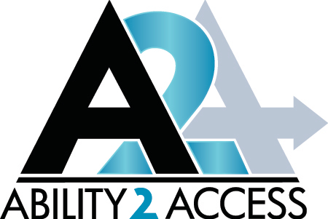

Logo description: The words Ability 2 Access below a large A 2 A with right arrow

Website: https://ability2access.com/
Ability2Access (A2A) provides schools, government agencies and individuals with the highest quality low vision and blindness products, software and trainings.

A2A is the authorized dealer for Freedom Scientific, Optelec, LVI, Irie-AT, HIMS, HelpTech, eSight and more. We have showrooms in both Radford, VA and Ashland, VA (both by appointment only).
The President, Julie Akers, of Ability2Access has over 17 years of experience in the low vision and blindness industry and is dedicated to improving the outcomes and facilitating the independence of individuals with visual impairments or blindness.

A2A will come to your home, school, or workplace to provide a free, no obligation on-site demonstration of the products. We value our customers and want to ensure their satisfaction and appropriate usage of the products by offering on-site delivery, set-up and basic training (at the time of delivery) for all products $1000 or more.

Contact Person: Julie Akers or Kendall Akers
Phone: 540-392-0388 (c) or 540-639-9732 (office)
Email: julie@ability2access.com or kendall@ability2access.com or Products@ability2access.com
# #

Breeden Inspirations
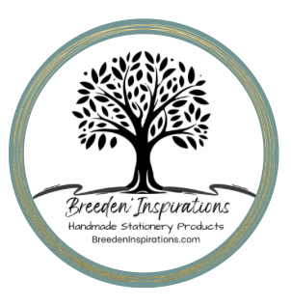

Logo description: The words Breeden Inspirations, Handmade Stationery Products below the roots of a Tree of Life.

In 2018, Theresa Breeden lost her central vision to Macular Telangiectasia 2. She turned that challenge into inspiration, creating low-vision stationery—journals, planners, and notebooks with bold lines, large print, and wide spacing. Each cover is a unique piece of art, designed by Theresa herself. Her work proves that vision loss doesn’t stop creativity—it transforms it.

Contact Person: Theresa Breeden
Phone: 540-621-4843
Email: breedeninspirations@gmail.com
Connect: Facebook | Amazon
# #

disAbility Resource Center of the Rappahannock Area, Inc. (dRC)

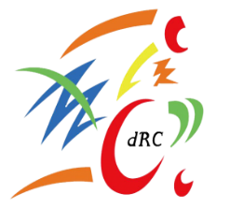

Logo description: Shapes of different colors with d R C in the center

Website: https://www.cildrc.org/
The disAbility Resource Center (dRC) empowers people of all ages and all types of disabilities to live as independently as possible. We achieve this through the five core services of Independent Living: independent living skills training, peer mentoring, advocacy, information and referral, and transition services. These services work together to support individuals in gaining the skills, confidence, and resources needed to lead self-directed, fulfilling lives.
dRC is one of 17 Centers for Independent Living in Virginia and 403 around the country. We work together, and in our communities, to advocate for change to ensure people with disabilities have access to programs and services.
The dRC believes that people with disabilities should always be fully included and valued members of their communities—because inclusion, equality, and participation are not privileges; they are rights.

Mission Statement
To assist people with disabilities in achieving their highest potential and the full benefits of independent living by providing them—and those who support them—and the community with information, education, and resources.

Objectives
- Serve people with all disabilities and of all ages to live independently.
- Promote independent living and full community inclusion for all.
- Ensure access for people with disabilities in all areas of community life.
- Advance awareness and appreciation of the abilities and contributions of people with disabilities.

Contact Person: Debra Fults, Executive Director
Phone: 540-373-2559
Email: dfults@cildrc.org
# #

Enhanced Vision
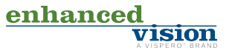

Logo description: The word enhanced in green and vision in blue, a Vispero brand
Website: https://www.enhancedvision.com/

Enhanced Vision is a leading developer of assistive technology for the visually impaired including Macular Degeneration, Glaucoma, Cataracts, Retinitis Pigmentosa and Diabetic Retinopathy. Low vision assistive technology enables people to read, write and fully participate in life.
Enhanced Vision has been at the forefront of the low vision field since its inception in 1996. We have brought many of the industry’s most innovative assistive technologies to the market. With a strong management background in medical devices, the company furthered the assistive technology market with the development of one of the first headworn magnifiers called the V-Max, now called JORDY. Today our product portfolio is considered one of the most diverse and reliable on the market.
Dedicated to helping individuals maintain their independence, Enhanced Vision has developed leading assistive technology to create a full line of superior, easy-to-use low vision tools at affordable prices. We pride ourselves for listening to our customers in order to develop the best assistive technology possible. Our assistive technology is offered by low vision professionals and can be found in specialized low vision agencies throughout the world. We are located in Orange County, California.
The Quality Policy at Enhanced Vision is to exceed customer’s expectation in everything we do. Through our customer focus and continuous improvement philosophy, quality is evident in every low vision device we design, manufacture, test and deliver. Emphasis on innovative technology, quality, and reliability coupled with our extensive distribution network provides our customers with superior products and services. We at Enhanced Vision take every measure to ensure quality, excellence and industry-leading processes throughout every single operation.

Serving Northern Virginia

Atlantic Low Vision


Logo description: A stylized eye with the words Atlantic Low Vision, Low Vision Solutions
Website: https://atlanticlowvision.com/
Atlantic Low Vision provides assistive technology for those with impaired vision. We create a personal relationship with our clients establishing a direct connection. We create this by providing a no obligation demonstration. This allows the client to see, feel, and use the machines we offer. We offer demonstrations at home or office, so we both can get a feel for the best solution for you. Phil Linz is the rep for Enhanced Vision products for northern Virginia.

Contact Person: Phil Linz
Phone: 703-888-7134
Email phil@atlanticlowvision.com :

Serving Southern Virginia

Advanced Vision (no website)
Advanced Vision Provides assistive Technology to those who are in need. I pride myself for quick and accurate evaluations for products that will meet the needs of the individual. I review with you the things that you want from a product and then show it to you to see how you do. I come to you to demo products to create a stress-free environment with a no obligation demonstration. I have been a representative for Enhanced Vision low vision products for almost 25 years. I have over the past 6 years picked up some other products to include in my portfolio.
I look forward to meeting each of you.
Contact Person: Allen Bareford
Phone: 804-400-1151
Email: bareford@comcast.net

# #

Foundation Fighting Blindness

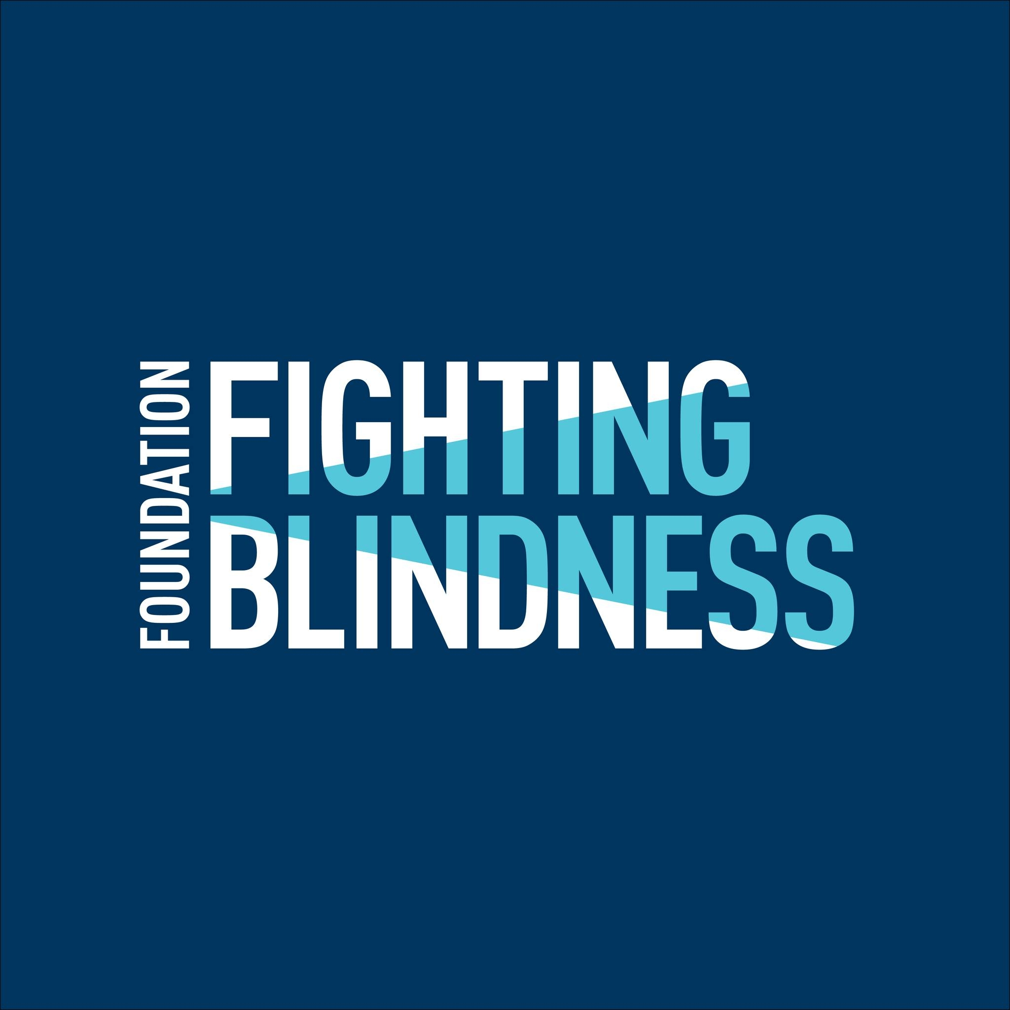

Logo description: The words Foundation Fighting Blindness in white letters on navy square with beam of light

Website: https://www.fightingblindness.org

The Foundation Fighting Blindness was established in 1971 by a passionate group of individuals determined to help find treatments and cures for blinding diseases affecting themselves or loved ones. At the time, very little was known about these devastating diseases that lead to blindness, and there were no clinical trials for potential treatments.
The Foundation’s goal was clear, and today the mission of the Foundation is to drive the research toward preventions, treatments, and cures for blinding diseases, including age-related macular degeneration, retinitis pigmentosa, Usher syndrome, Stargardt disease, Leber congenital amaurosis, and more. Together, these conditions affect more than 10 million Americans and millions more worldwide.
An additional goal of the DC Metro chapter is to provide support, resource connections and helpful information to those with any vision issue. Both in-person and virtual meetings are scheduled a few times a year to help foster these connections.
At the convention Davida will have printed documents for sighted or low vision attendees. She will also provide materials electronically to anyone who would like them in that format. She may also have a flyer for an in-person event in November, program TBD.

Contact Person: Davida Luehrs
Phone: 703-819-8621
Email: davidaluehrs@gmail.com
# #

Guiding Eyes for the Blind
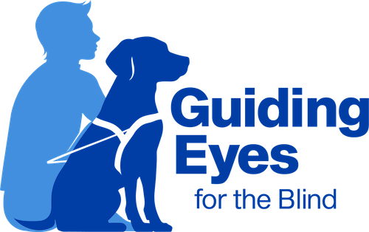
Logo Description: Man and guide dog sitting next to the words Guiding Eyes for the Blind

https://www.guidingeyes.org/

Guiding Eyes for the Blind provides guide dogs to people with vision loss. We are passionate about connecting exceptional dogs with individuals for greater independence.
Since 1954, Guiding Eyes has graduated more than 10,000 guide dog teams. We believe in the powerful, meaningful change that our beautiful dogs bring to the lives of people facing the daily challenges that blindness and vision loss present.
It can cost up to $50,000 annually to train and care for a guide dog throughout its working lifetime with a person who is blind. As a 501(c)(3) nonprofit organization, we provide all services completely free of charge to people who are blind or with vision loss. At Guiding Eyes, we rely upon the contributions of our generous donors to fulfill our mission.
Contact Person :
Melissa Carney : mcarney@guidingeyes.org
Madeline Bruggeman: MBruggeman@guidingeyes.org

Guide Dog Users Inc
This is a network of affiliates of guide dog users across the United States.
Contact Person: Cindy Labon: cindylabon@gmail.com
# #

JW.org



Logo description: White letters JW.org on blue square

Website: https://www.jw.org/en/

Jehovah’s Witnesses are a global religious organization that can be found in 240 lands. We are Christians who believe in Jesus Christ and that he is God's son. We base our beliefs solely on the Bible. While we primarily help our local communities with our bible-based education work, we also provide support in other ways. We invite you to explore this further using the link below:

Louis Braille—Bringing Light to Prisoners of Darkness

JW.ORG provides many free Bible study aides for those who are blind or visually impaired. These include Braille and large print publications. Also, audio publications can be accessed via JW.ORG, JW Library and Alexa. Additionally, screen reader (RTF) and notetaker (BRL) files as well as DAISY and MP3 formats are available. Videos with audio descriptions are also published on JW.ORG. These resources assist individuals, married couples as well as their teens and young children to have uplifting Bible-based information that assists them to face daily challenges successfully and provide answers to life’s big questions.

Contact Person: Kevin Burrus
Phone: 845-430-1408
Email: kwburrus@gmail.com
Contact Us
# #

Lions



Logo description: The words Lions International in blue and L in gold on shield with lion’s head on left and right

Website: https://e-district.org/sites/md24/
In 1917 Melvin Jones, a 38-year-old Chicago business leader, told members of his local business club they should reach beyond business issues and address the betterment of their communities and the world. Jones’ group, the Business Circle of Chicago, agreed.

The mission of the Lions is to empower volunteers to serve their communities, meet humanitarian needs, encourage peace, and promote international understanding through Lions Clubs.
Lions are constantly seeking civic minded citizens who are willing to donate some time and effort toward making our communities better places in which to live. If you are interested in visiting a Lions Club, please contact Davida Luehrs to receive an invitation to a local Lions Club. You can join us and learn more about what Lions really do to help their fellow man. Membership in a Lions Club is by invitation only; however, the only requirements are to be of legal age and good character. Through membership, Lions not only help people in need, but they have opportunities to develop personal friendships and gain valuable leadership skills which can be used in their work or in their personal lives.
At the convention Davida will be selling the 2025 White House Ornaments that the Reston Lions sell as well as the Virginia peanuts. She will provide the flyers electronically in advance and will take orders in advance of the convention. She will also certainly take orders at the convention.

Contact Person: Davida Luehrs
Phone: 703-819-8621
Email: davidaluehrs@gmail.com
# #

National Industries for the Blind (NIB)
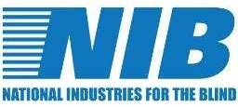

Logo description: N I B and National Industries for the Blind in blue on white background

Website: https://nib.org/
NIB is the nation’s largest employment resource for people who are blind, and through its network of associated nonprofit agencies, is the largest employer of people who are blind in the country. We create opportunities for people who are blind to become wage earners and taxpayers, reducing their reliance on government support and increasing engagement with their communities.

NIB connects its associated agencies with manufacturing and service delivery opportunities with the federal government and commercial companies. Our customers get the business solutions that they need, and people who are blind are employed—it’s a win-win. We offer career training, which is crucial to getting Americans who are blind employed and keeping them employed. Today, thousands of people who are blind are using these skills in state-of-the-art manufacturing and professional services careers.
NIB’s impact is made possible through the sale of SKILCRAFT® products and services produced and delivered by people who are blind. SKILCRAFT is a registered trademark owned and licensed by NIB. The SKILCRAFT line includes thousands of offerings — from office supplies and hardware to knowledge-based professional services — that meet or exceed exacting government standards, including the rigorous requirements of the U.S. military.

NIB’s vision is that blindness is not a barrier to employment.
NIB’s mission is to enhance the personal and economic independence of people who are blind, primarily through creating, sustaining, and improving employment.

At the convention Kathy Gallagher will be talking about employment opportunities with NIB and their associated agencies and will collect resumes from anyone who has a resume with him/her.

Contact Person: Kathleen Gallagher, Learning and Development Manager
Phone: 703-310-0500
Email: Kgallagher@nib.org
# #

Patriot Vision Industries
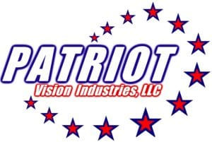

Logo description: White words Patriot Vision Industries, LLC in white over an array of blue bordered red stars.

Website: https://patriotvisionindustries.com/
Family owned and operated by President and founder John D. Palmer, We specialize in and manufacture technology under the exclusive PATRIOT brand for all sorts of visual needs! We help you select the right technology to meet YOUR specific needs and to reach your functional goals. Matching technology to the person is what we do!!
PATRIOT VISION INDUSTRIES LLC, nestled in the rolling hills of central Florida, proudly designs, manufactures and distributes innovative assistive technology under our PATRIOT brand.
Pioneers in the industry, we continually strive to empower our customer's lives with our award-winning products and improve the quality of life for those we serve.
Patriot is the brand you can trust. Please call today to schedule a demonstration with one of our authorized dealers in your area, worldwide, or to receive more information or place your order!
Patriot Industries has products that harvest AI which can do item descriptions, read barcodes, electric bills and count money. Patrio also provides portable CCTV’s with OCR reading, along with digital magnifies and a wearable that harvest the OCR reading and contrast color adjustment options.

Contact Person: Haley Lan, National Account Executive
Phone: 470-313-4116
Email: haley@patriotvision.com
# #

Prevention of Blindness Society of Metropolitan Washington


Logo description: the words Prevention of Blindness Society of Metropolitan Washington below a stylized eye.

Website: https://www.youreyes.org/
Founded in 1936, POB is dedicated to the improvement and preservation of sight and quality of life by providing services and education, and by championing healthy vision and innovation to everyone in our area.
Each year, POB impacts approximately 13,000 community members through our evidence-based programs — including vision acuity and glaucoma screenings, eyeglasses distributions and fittings, educational vision resources and events, low vision rehabilitation services and support group networks, and more. We remain committed to comprehensive vision health, ethical service within the community, deep respect for individuals and families in all circumstances, innovation in service delivery, and serving as a facilitator among our medical and social service peers.
Our organization serves the District of Columbia, Northern Virginia, and Montgomery and Prince George’s Counties of Maryland.
Contact Person: Tara Aziz, Senior Coordinator, Low Vision Programs
Phone: 202-234-1010
Email: taziz@youreyes.org

# #

Selvas BLV

Logo description: The words Selvas BLV

Website: https://selvasblv.com/

‘SELVAS’ translates to “rainforests” or “jungles,” and symbolizes growth, resilience, and interconnected ecosystems.
‘BLV’ stands for blind and low vision.
We launched our first Braille notetaker in 2001. Since then, we have refined our products to become top-of-the-line refreshable braille displays, braille tablets, multimedia players, and more.

Contact Person: Earl Harrison, National Account Manager
Phone: 512-914-1925
Email: earle@selvasblv.com
# #

Sportable Richmond Adaptive Sports and Recreation


Logo description: the word sportable in orange and navy next to stylized raised arms.

Website: https://sportable.org/
Founded in 2005, Sportable creates opportunities and transforms the lives of individuals with physical disabilities, visual impairments, and those requiring physical accommodations through sport, recreation, health, and wellness.
As Central Virginia's premier adaptive sports club, Sportable provides sport and wellness opportunities to more than 400 athletes each year by offering a variety of competitive and recreational adaptive sports programs.
Our athletes are of all ages, come from different backgrounds, and have varying abilities.
By fostering a fun, inclusive, competitive, and accessible environment, we transform the lives of our athletes and free them to see beyond their disability, enhance their peer relationships, and help them to reach their personal finish line.

Contact Person: David Robbins, Community Outreach Manager
Phone: 804-340-2991
Email: david@sportable.org
# #

Vanda Pharmaceuticals

Logo description: VANDA over the word Pharmaceuticals Inc.

Website: https://www.vandapharma.com/
Vanda is a global biopharmaceutical company focused on the development and commercialization of innovative therapies to address high unmet medical needs and improve the lives of patients.
Non-24-Hour Sleep-Wake Disorder
Non-24 (Non-24-Hour Sleep-Wake Disorder) is a circadian rhythm disorder that causes a person's internal body clock to become out of sync with the 24-hour day. Non-24 has High Prevalence and Low Awareness in the Blindness Community. Up to 70% of people who are totally blind may have Non-24 and may not even know it. People living with Non-24 may experience trouble falling asleep and staying asleep, have a strong urge to sleep during the day, and have sleep patterns that are different from most people.

Contact Person: Magdalena Felton, Clinical Nurse Educator – Patient Outreach
Phone: 202-579-8035
Email: Maggie.felton@vandapharma.com
# #

Virginia Department for the Blind and Vision Impaired
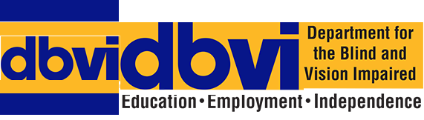

Logo description: blue letters dbvi on gold. Department for the Blind and Vision Impaired. Education, employment, independence in black

Website: https://www.dbvi.virginia.gov/

The Department for the Blind and Vision Impaired (DBVI) is a state agency that helps individuals in Virginia who are blind, vision impaired, or deafblind. DBVI provides people with the tools, support, and job opportunities they need to reach their desired levels of employment, education, and personal independence.

DBVI works with people of all ages across Virginia. The agency offers special programs and services to help people learn new skills, find jobs, and become more independent. With help from DBVI, people can feel more confident and ready to take part in their communities.

DBVI has a team of trained and committed staff who work with each person to create a plan that fits their needs. Services are offered in local communities and at the Virginia Rehabilitation Center for the Blind and Vision Impaired in Richmond. Everything DBVI does is focused on supporting individuals to build the skills, confidence and positive attitude needed to achieve their goals.

To learn more about DBVI’s programs, services, and job opportunities, visit their website.

Contact Person: Rick Mitchell, Commissioner
Phone: 800-622-2155, or 804-371-3140.
Email: rick.mitchell@dbvi.virginia.gov
Or
Contact Person: Becky Keller, PreETS Specialist
Phone: 804-845-0685
Email: becky.keller@dbvi.virginia.gov
# #

Visionary Solutions


Logo description: the words Visionary Solutions in white on navy background.

Website: https://www.visionarysolutions.online/

Michael Beattie can help you and your child – whether you are struggling to get the right IEP (Individualized Education Program) in place for your child or you are trying to determine which schools or educational programs would be best suited for your child.

Michael has the education, training, and practical experience to help you effectively navigate the difficult world of special education. Since he went through the special education system to get needed services for himself, he can empathize with and understand your challenges. He is well versed in reading and analyzing test scores, reports and IEPs, and applying that knowledge to help achieve the best possible education for your child. He is familiar with the school culture, both public and private, and can help guide you through difficulties with a school, or help to choose the school that may be the right fit for your child.
He is also well informed regarding the local professionals in such fields as Testing, Speech and Language, Visual and Auditory Processing, Neuro-psychology, and Occupational Therapy. He can help you select the right professionals to help you best support your child. He is an expert at seeking and obtaining positive results even in contentious and sometimes hostile situations.

At the convention he will also be announcing the creation of a resume bank of blind job seekers and searching for contracts that would provide employment for people in the resume bank.

Contact Person: Michael Beattie
Phone: 703-994-8619
Email: michaelbeattie@yahoo.com
# #

Goodie Bag and Door Prize Contributors

Access To Places
Website: https://accesstoplaces.com
Contact Person: Antonio Guimaraes
Phone: 954-222-2377
Email: info@accesstoplaces.com

Irie-AT
Website: https://irie-at.com
Contact Person: Cody Mitchell
Phone: 541-257-1032
Email: cody.mitchell@irie-at.com

Leader Dogs for the Blind
Website: https://www.leaderdog.org
Contact Person: Leslie Hoskins
Phone: 248-651-9011
Email: leslie.hoskins@leaderdog.org

MedRVA
Website: https://www.medrva.com/
Contact Person: Marianne Johnson, Fundraising Coordinator
Phone: 719-322-6896
Email: marianne.johnson@medrva.com

Prevention of Blindness of Metropolitan Washington
Website: https://www.youreyes.org/
Contact Person: Tara Aziz, Senior Coordinator, Low Vision Programs
Phone: 202-234-1010
Email: taziz@youreyes.org

Six Dot Paws
Website: https://sixdotpaws.company.site/
Contact Person: Cole Bischoff, or his mother, Danielle Bischoff
Phone: 703-856-3923
Email: sixdotpaws@gmail.com

The Seeing Eye
Website: https://seeingeye.org/
Contact Person: Chelsie White
Phone: 973-539-4425
Email: whitec@seeingeye.org

VisualEyes Access
Website: https://visualeyesaccess.com/
Contact Person: Shawn Welker
Phone: 517-630-1420
Email: Shawn@VisualEyesAccess.com
# # #

In Gratitude

Program Planning and Convention Logistics Committees

No convention can happen without the dedication, time, and talent of many individuals. From designing the program to coordinating logistics—securing space, arranging food, recruiting vendors, and raising donations—these committees make it all possible.

Program Planning Committee
Co-Chairs: Sue Bowmaster & Sam Joehl
Members: RoseAnn Ashby, Donna Clarke, Margie DeMars, Tina Egge, Jeremy Grandstaff, Debra Hill, Robin Hoerber, Davida Luehrs, Doug Powell

Convention Logistics Committee
Convention Coordinator: RoseAnn Ashby
Assistant Coordinator: Theresa Breeden
Members: Donna Clarke, Margie DeMars, Debra Hill, Maria Evangelista, Susan Hedrick, Dennis Helms, Robin Hoerber, Davida Luehrs, Martin Pfeifer, Doug Powell

Session Facilitators and Presenters

A heartfelt thank you to everyone sharing their expertise and leading engaging sessions:
Keynote Banquet Speaker: Debra Hill
Icebreaker: Margie DeMars & Robin Hoerber
Leadership Training: Doug Powell & Jeremy Grandstaff
Advocacy: RoseAnn Ashby
Household Management: Vicki Ratcliffe & Sam Joehl
Emergency Preparedness: Donna Clarke & Crystal Goodwin
Falls Prevention: Doug Powell & Larry Johnson
Assistive Technology & Artificial Intelligence: Jeremy Grandstaff & Stan Gowin.
# # #

Special Thanks

Rick Morin, Media and IT Manager from the national office of the American Council of the Blind, has been instrumental in designing and executing our hybrid program. His expertise and support made this convention possible.

Patrick Hope and Rodney Willett, two Virginia state delegates, bring special expertise about the state legislative process and how to advocate effectively. We are indebted to them for their willingness to take time out of their busy schedules to speak with us in person on a Saturday morning. We will be better prepared to lobby in Richmond this winter as a result of their wise counsel.

Kerry Devine, the Mayor of Fredericksburg, graciously accepted our invitation to speak with us on the first evening of the convention. We so appreciate her willingness to take the time to welcome us to her city.
# # #

Thank You to Our Local Business Donors

We are grateful for the generous support of these local businesses, whose contributions help make our convention a success:

- Breeden Inspirations
Fredericksburg, VA
- Chick-fil-A
1094 International Pkwy, Fredericksburg, VA 22406
- Costco
3102 Plank Rd #600, Fredericksburg, VA 22407
- Krispy Kreme
1891 Carl D Silver Pkwy, Fredericksburg, VA 22401
- Skechers
1370 Carl D Silver Parkway Bldg 5, Fredericksburg, VA 22401
- Staples
2003 Plank Rd, Fredericksburg, VA 22401
- Witches Brew Café
Locust Grove, VA
# # #

Patrons:
Thanks to our many friends and allies who provided financial support for our convention.

Anonymous – Thank you!
Jerilyn Anderson
China Archer
RoseAnn Ashby
Marjorie Barclay
Sue Bowmaster
Theresa Breeden
Lois Butterfield
Lisa Calhoun
Barbara Coffey
Suzanne Cox
Margie DeMars
Tina Egge
Alex Erby
Maria Evangelista
Pamela Frick
Andrea Glosser
Mariane Herndon
Debra Hill
Robin Hoerber
Pamela Johnson
Barbara Kreutzer
Keith and Carol Kurtz
Loretta Lacorte
Ninette LeGates
Leslie Lenny
Doug Powell
Melody Rawles
Abigail Reynolds
Schuyler Richardson
Margaret Scott
Vicki Ratcliffe
James VanDevender
Gail Wiltshire
# # #

Volunteers:
No convention would be possible without the tireless work and support provided by our wonderful volunteers. Thank you - - you are awesome!

Sally Cooney Anderson
Liana Ashby
Marjorie Barclay
Misti Battle
Linda & Adam Binion
Stacy Curley
Rebecca DeJesus
Marietta D’Ostilio
April French
Christine Frescas
Grant Gates
Linda Hahn
Heather Held
Relda Larquet
Louisa McClanahan
Ken Melendez
Tom & Judy Morgan
Sharifa Mosavi
David Palmer
Traci Rasdorf
Jody Silverberg
# # #

ACBVA 2024-2025 Board of Directors

Doug Powell, President
president@acbva.org

RoseAnn Ashby, Vice-President
roseann@acbva.org

Sue Bowmaster, Secretary
s.bowmaster@cox.net

Theresa Breeden, Treasurer
treasurer@acbva.org

Donna Clarke, Board Member
catclover22@gmail.com

Debra Hill, Board Member
debra_hill4@yahoo.com

Susan Hedrick, Board Member
sueva48@gmail.com

Sam Joehl, Immediate Past President
blink183@verizon.net

